RECOMMENDATION SYSTEM
(1). Model used for Recommendation System (Hepatitis Model):
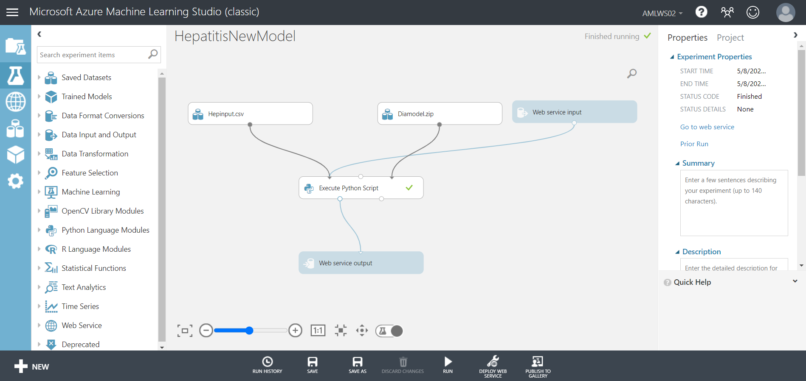
This is the model that we have used for our Recommendation System.

(2). Web-Services used for the Recommendation System:
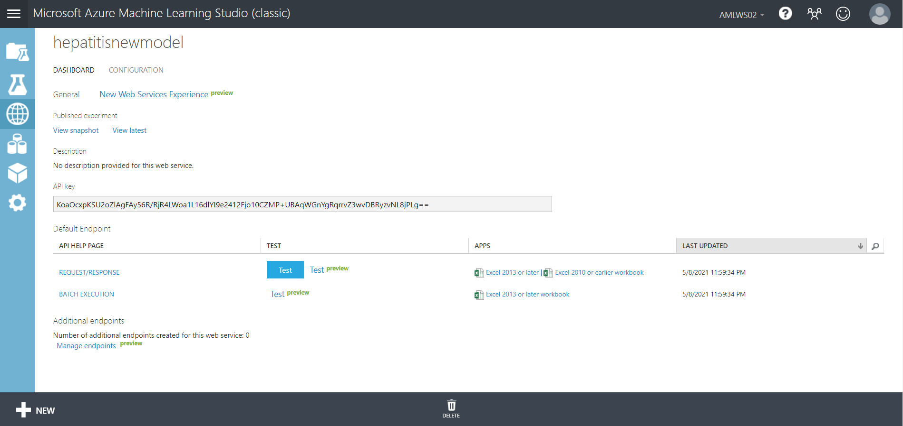
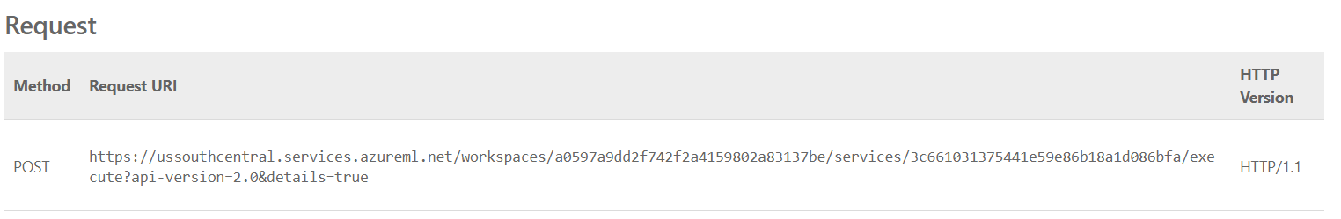
After deploying the ‘Hepatitis’ model, this is the web-service that we have used for our recommendation system. In our recommendation system we have used the ‘API Key’ and the ‘Request URI’ so that our recommendation bot can fetch the data from our model while using it.
(3). Recommendation system techniques:
A recommendation engine is a system that proposes products, administrations, data to users based on analysis of data. Notwithstanding, the recommendation can get from an assortment of variables like the historical backdrop of the user, and the conduct of comparative users.
Fig-1: Recommendation system techniques
(4). Design and build a chatbot:
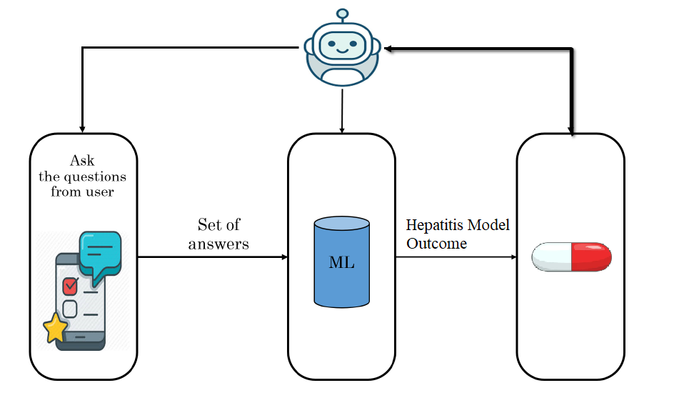
Fig-2: Outline of the Hepatitis chatbot

(5). Chatbot using Telegram:
We’re going to build a bot using the Telegram Application. First, we need to register a chatbot using ‘BotFather’.
To do this:
- Search @BotFather in telegram search box. Or use ‘https://t.me/BotFather’ directly.
- Create a new bot by telling him /newbot command.

After providing a name and a username, we will be given a bot name and a token:

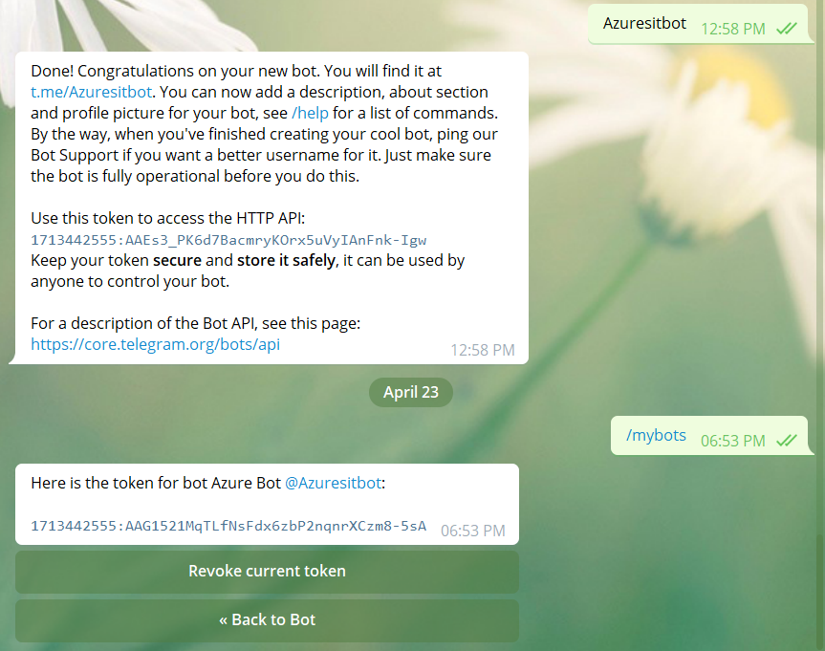

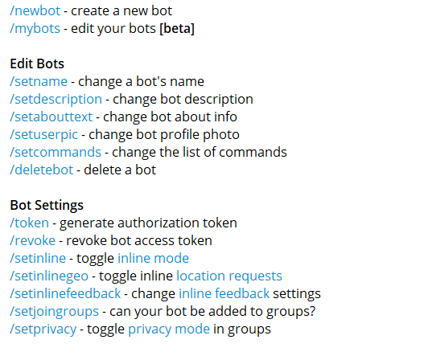
We can even edit the name, token, bot description, privacy, profile photo and many more setting by using these commands from above.

(6). Install Libraries used for chatbot:
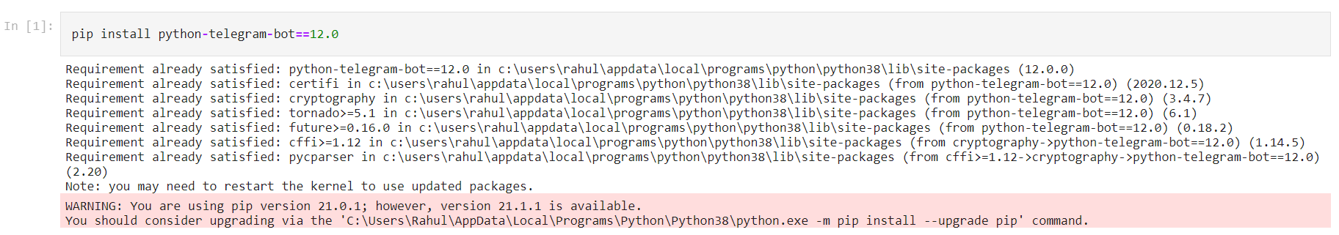
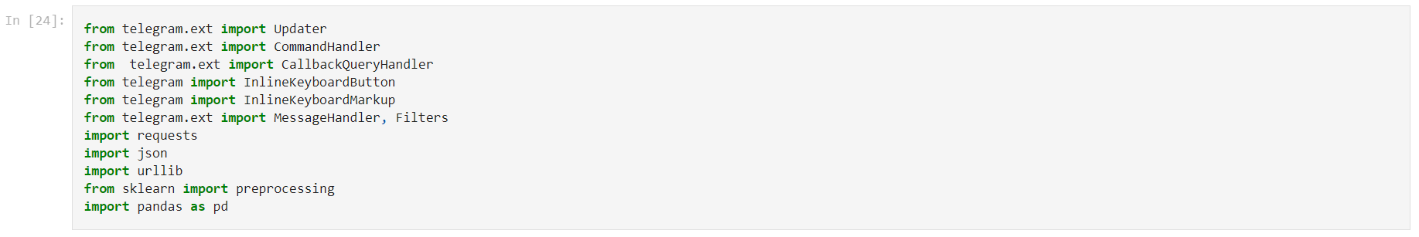
First, we’ll install the python telegram bot so that we can use the telegram bot services in our python.
(A). ‘from telegram.ext import Updater’:
It plays the main role to control the conversation between the bot and user.
1. This class associates the user to the chatbot page which is made by 'Botfather' (interface the user to the bot).
2. It handles every one of the user's and bot's inputs by running the functions which is created for this reason as it were.
3. It stops the proposed functions when there is no need any longer to send or get message or inquiry among user and bot through the functions.
(B). ‘from telegram.ext import CommandHandler’
‘from telegram.ext import CallbackQueryHandler’
‘from telegram.ext import Message Handler, Filters’
These libraries are used for sending message from user to bot.
(C). ‘from telegram import InlineKeyboardButton’
‘from telegram import InlineKeyboardMarkup’
These libraries are used for sending message from bot to user.
(D). import requests
import json
import urllib
from sklearn import preprocessing
import pandas as pd
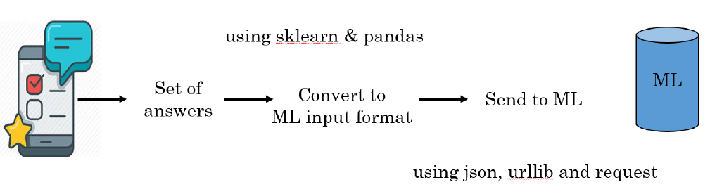
(7). Adding Token and Request URI:
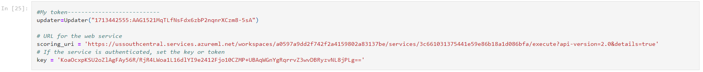
We’ll add the token from Botfather that we have received after making the bot in the ‘updater’ section which will act as an interface between the user and the bot. We’ll also add the ‘Key’ & ‘Request URI (or scoring uri)’ from the Hepatitis model that we have deployed on Azure.
(8). Start function of the Bot:
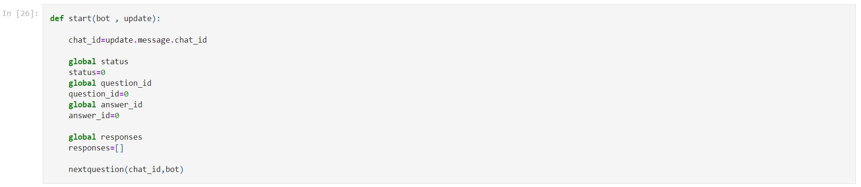
Here the bot and update will be sent to the start function. We’ll start the bot in Telegram using ‘/start’. Update stores the information of updated chat, like chat.id. In this function, entering ‘/start’, should make the bot Jump to the next question (nextquestion function will do this part).

(9). Next Question function of the Bot:

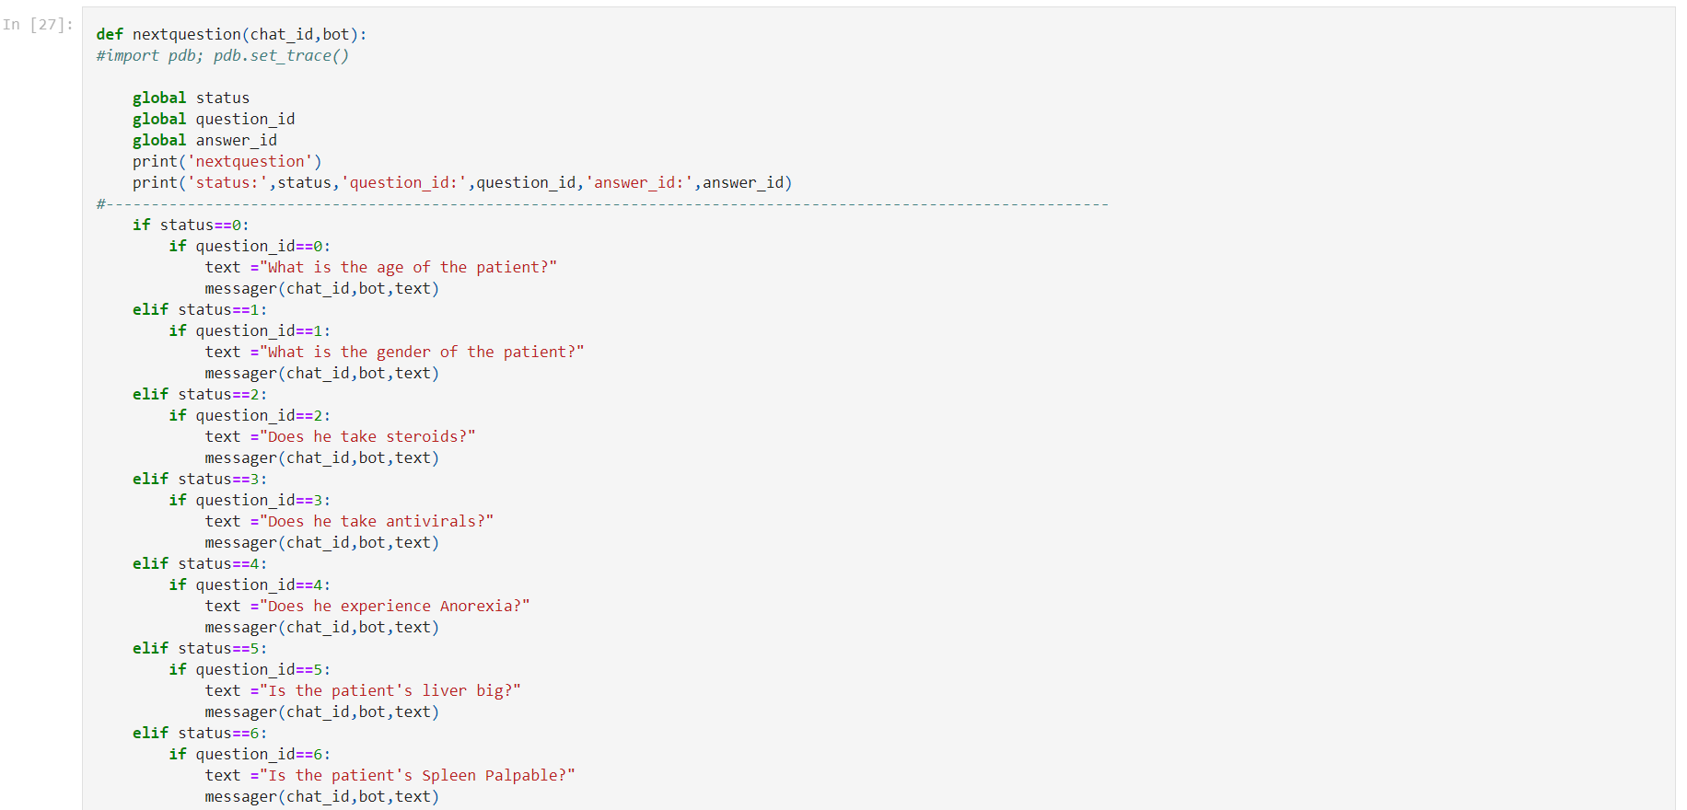

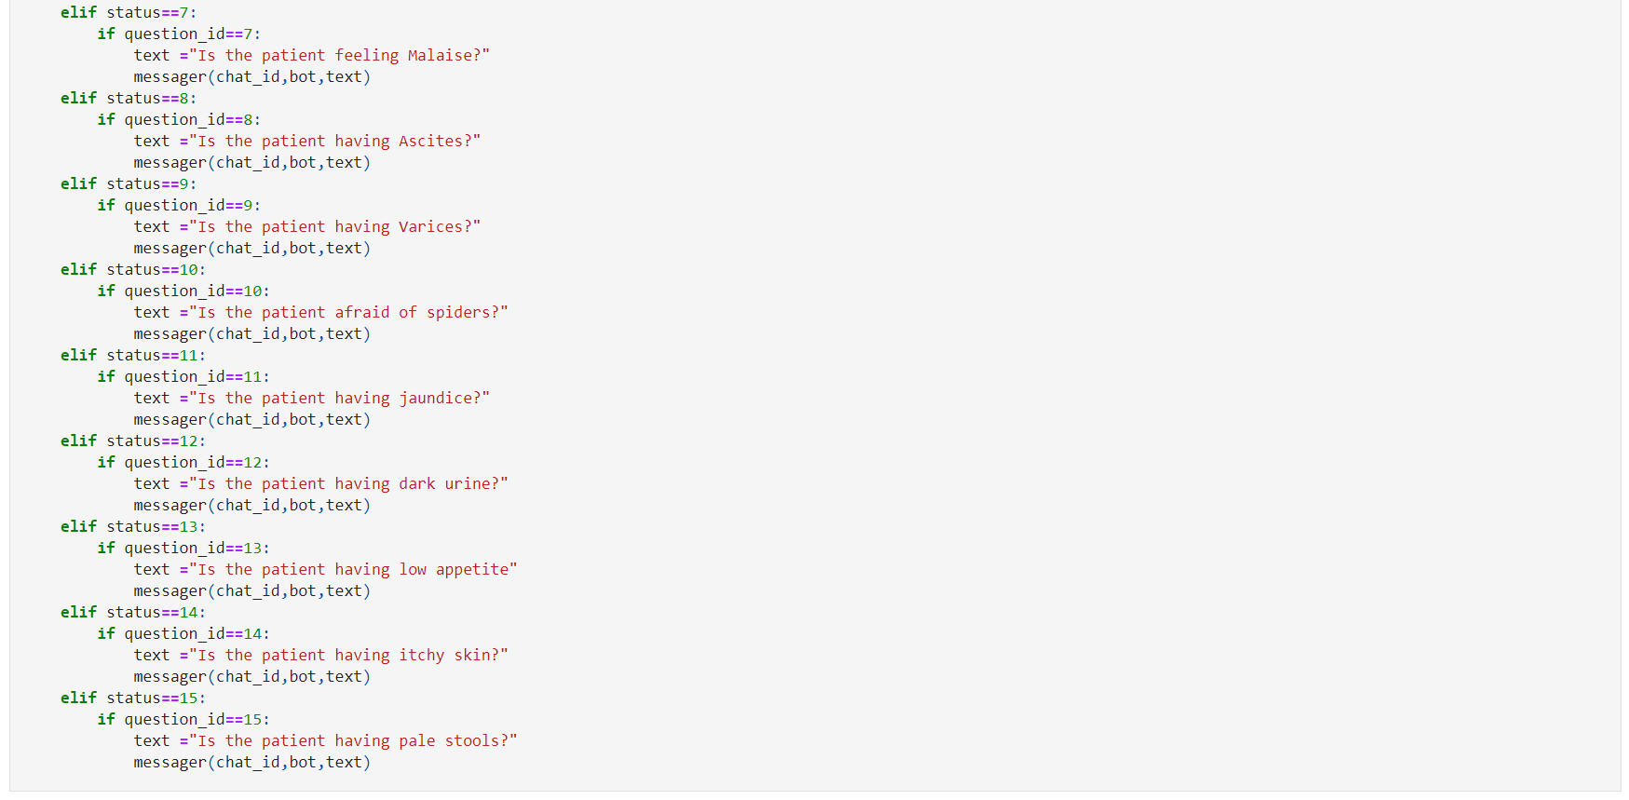
In this function we’ll create the questions that will be asked by the bot (as question_id) & answers that’ll be provided by the user according to the deployed model dataset (as answer_id). The status will update after every question which will automatically lead to the next question.
(10). Messager Function:
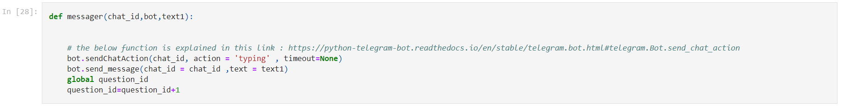
This function is used to send questions to the bot.
SendChatAction: Utilize this strategy when you need to tell the user that something is going on the bot's side. The status is set for 5 seconds or less (when a message shows up from your bot, Telegram clients clear its typing status). Telegram possibly suggests utilizing this technique when a response from the bot will set aside an observable measure of effort to show up.
(11). ContQuestions Function:
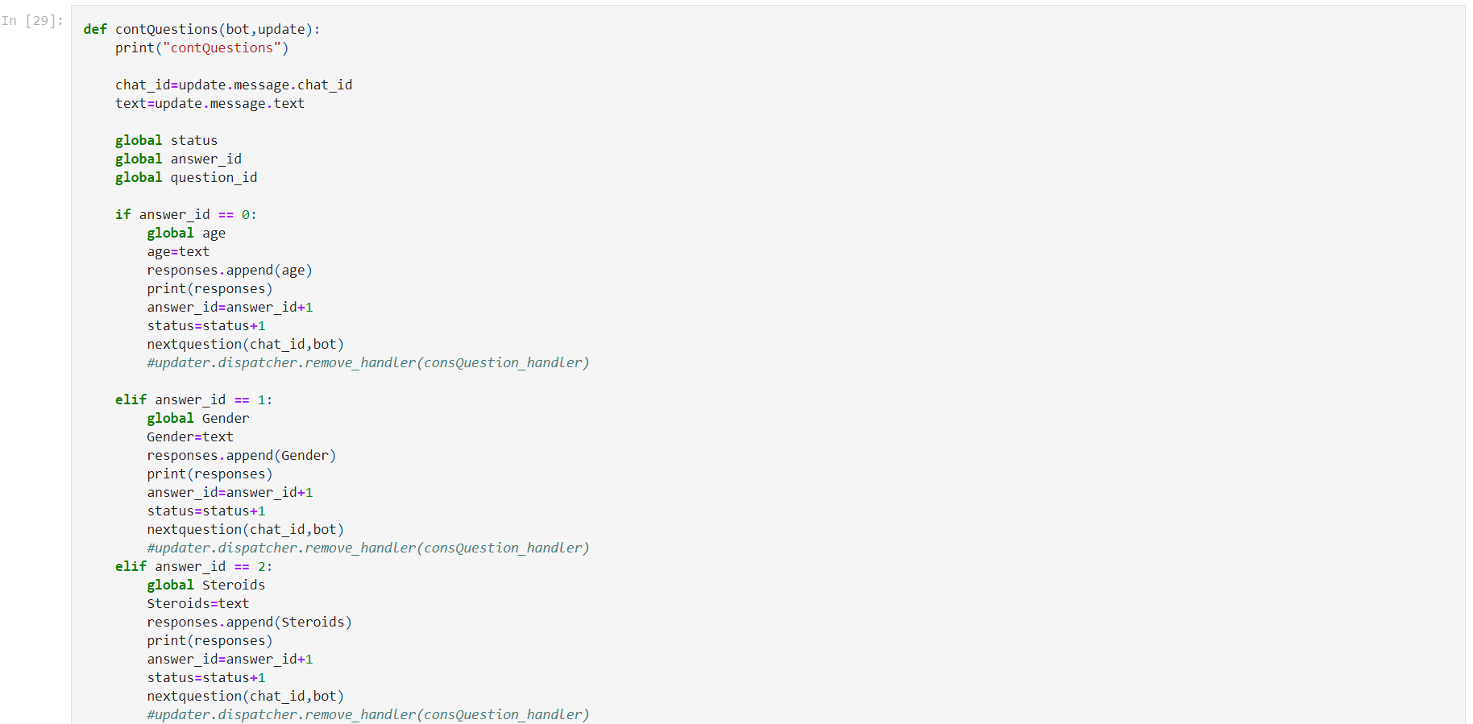
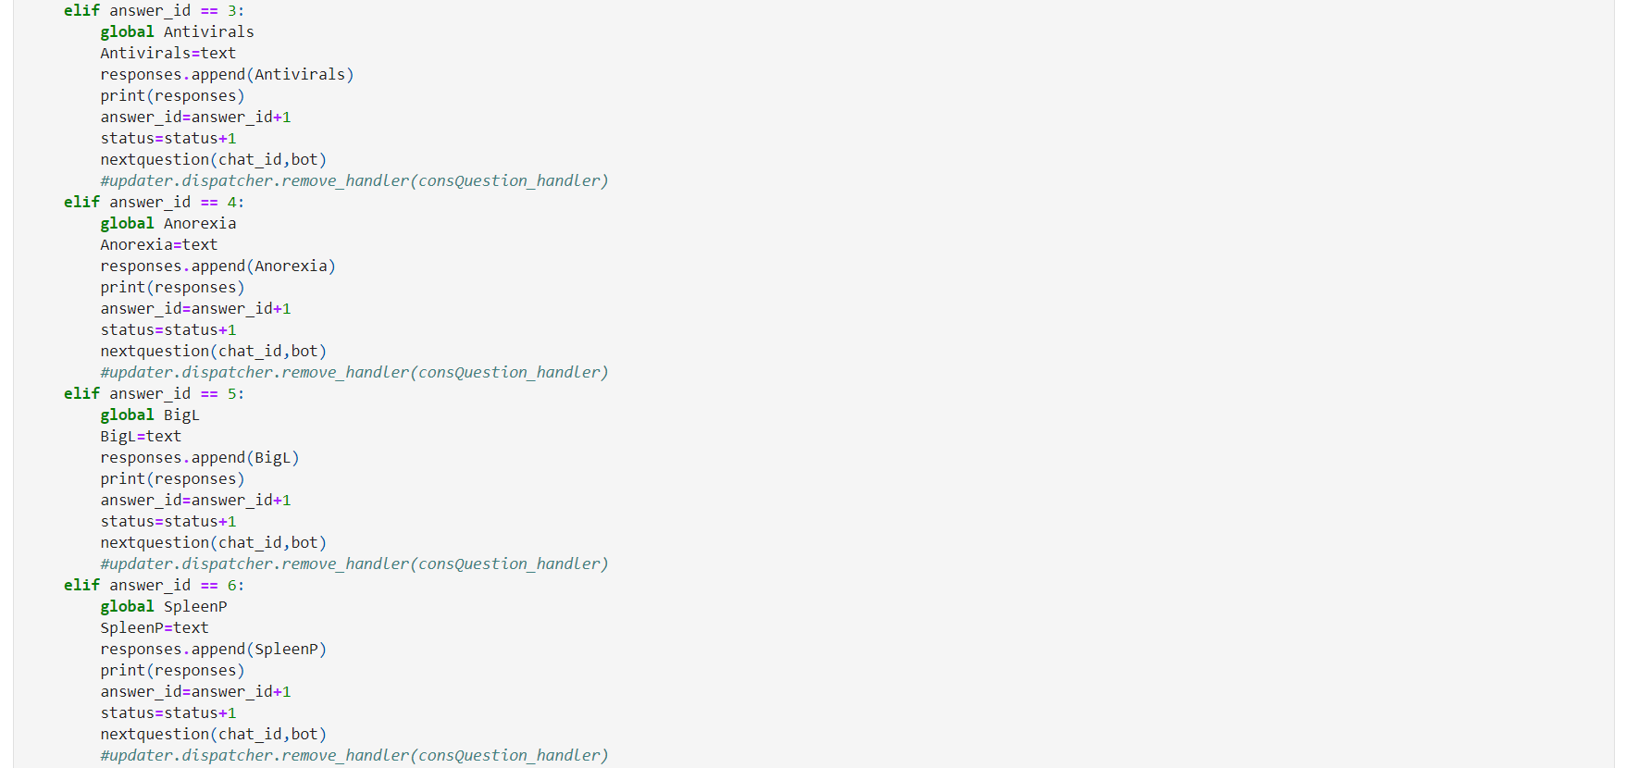

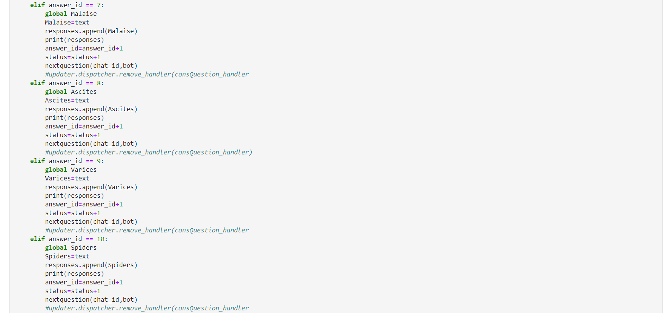
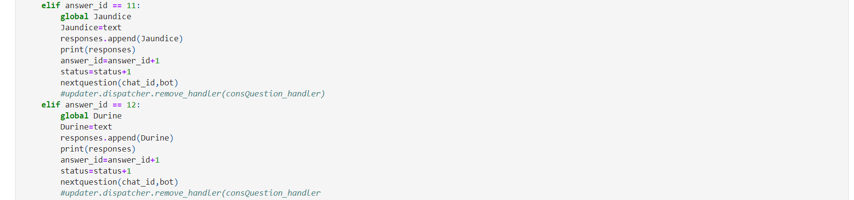

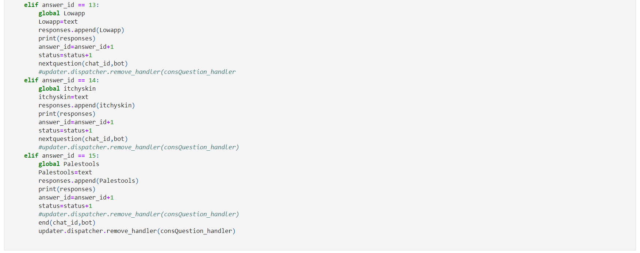
This function gets the text (update.message.text ) from the user and stores the messages entered by the user. If the user is using text answers then only, we can use this function. We’ll make global variables to every answer_id and pass it to program.
(12). End Function:
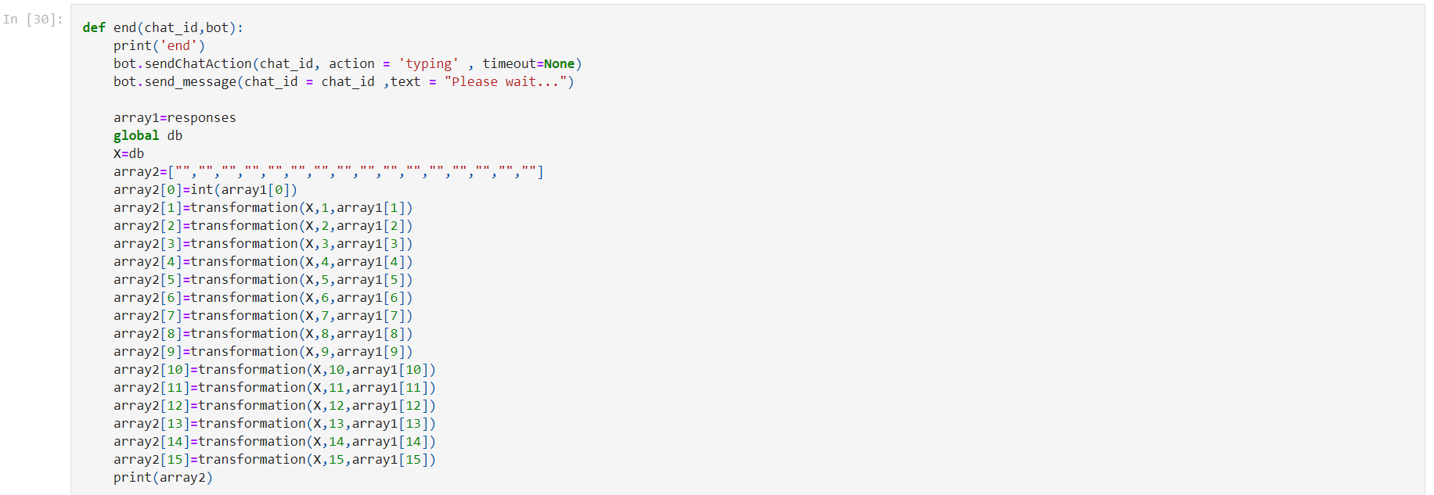
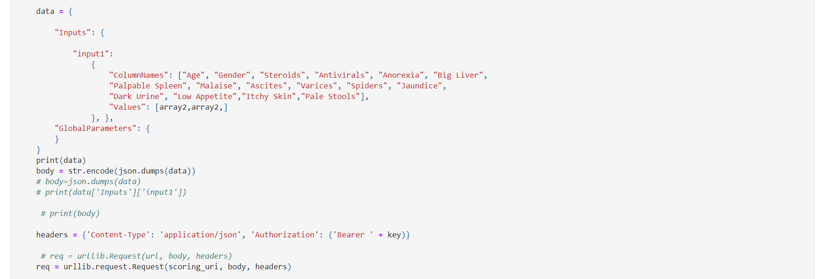

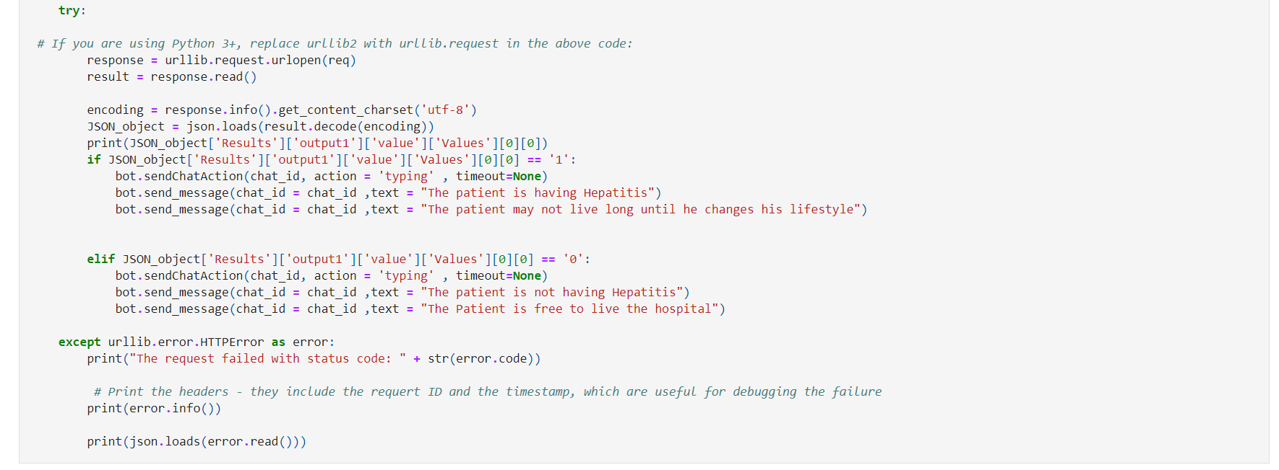
In the ‘end function’ we’ll store all the user’s response into an array. The ‘end function’ will send all the user’s response to the deployed ML model (Hepatitis Model).
To send the information we’ll use JSON for information exchange. Following methods are available in the JSON module:
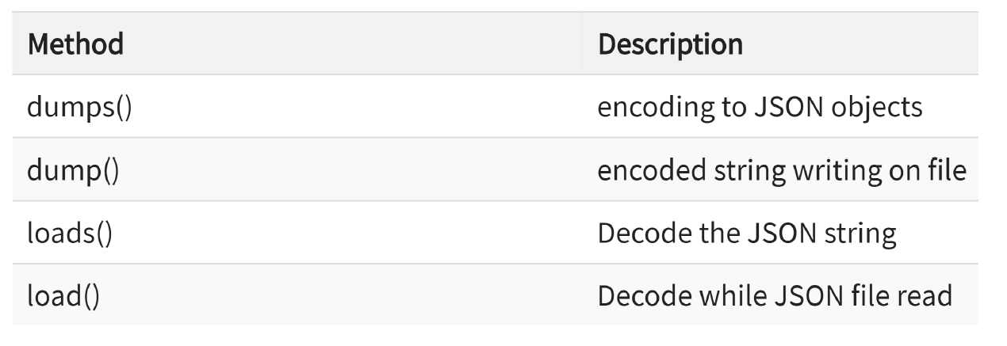
From Python data to JSON:
Converting Python data to JSON is called an ‘Encoding operation’. Encoding is done with the help of JSON library method called as ‘dumps()’.
dumps() method converts dictionary object of python into JSON string data format and it can be found in the ‘Request Response API Documentation for the used Model’ in the sample code section (in Python).
We’ll send the data to ML model on Azure using the ‘Scoring URI & Key’ of deployed ML model.
After that we’ll convert the JSON information to python for our required output.
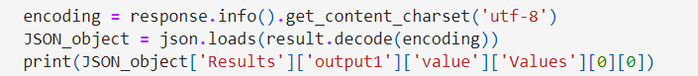
The Recommendation will be:
After answering all the questions according to our dataset we’ll be arrived at this recommendation by our designed bot:
If class label=1, it means that the "The patient is having Hepatitis".
If class label=0, it means that the "The patient is not having Hepatitis".

(13). Main:
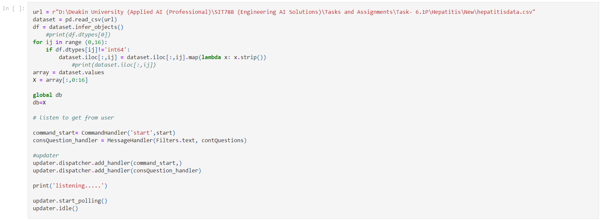
Here, first we’ll add the dataset which will be used for prediction (hepatitisdata.csv). In this class, which utilizes the telegram.ext.Dispatcher, gives a frontend to the telegram Bot to the developer, so they can zero in on coding the bot. Its motivation is to get the updates from Telegram and to convey them to said dispatcher. It additionally runs in a separate thread, so the user can connect with the bot, for instance on the command line. The dispatcher upholds handlers for various types of data updates from Telegram, fundamental text commands and surprisingly arbitrary types.
Idle: Blocks until one of the signals are received and stops the updater.
start_polling: Starts polling updates from Telegram.
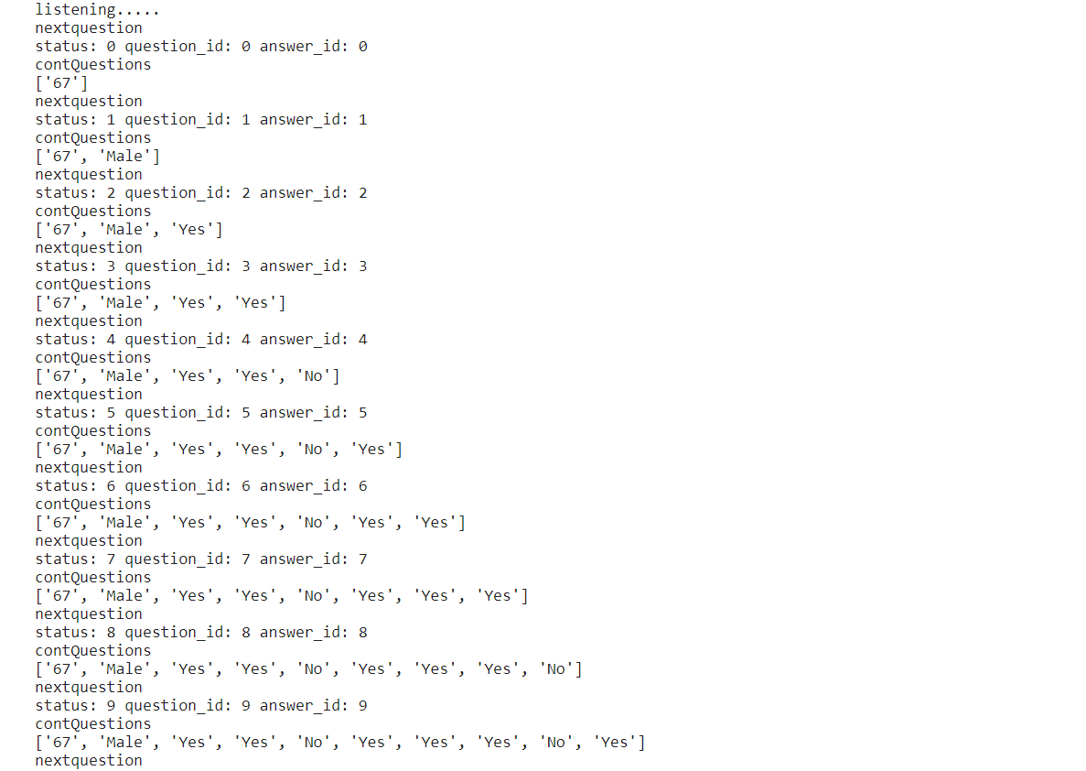

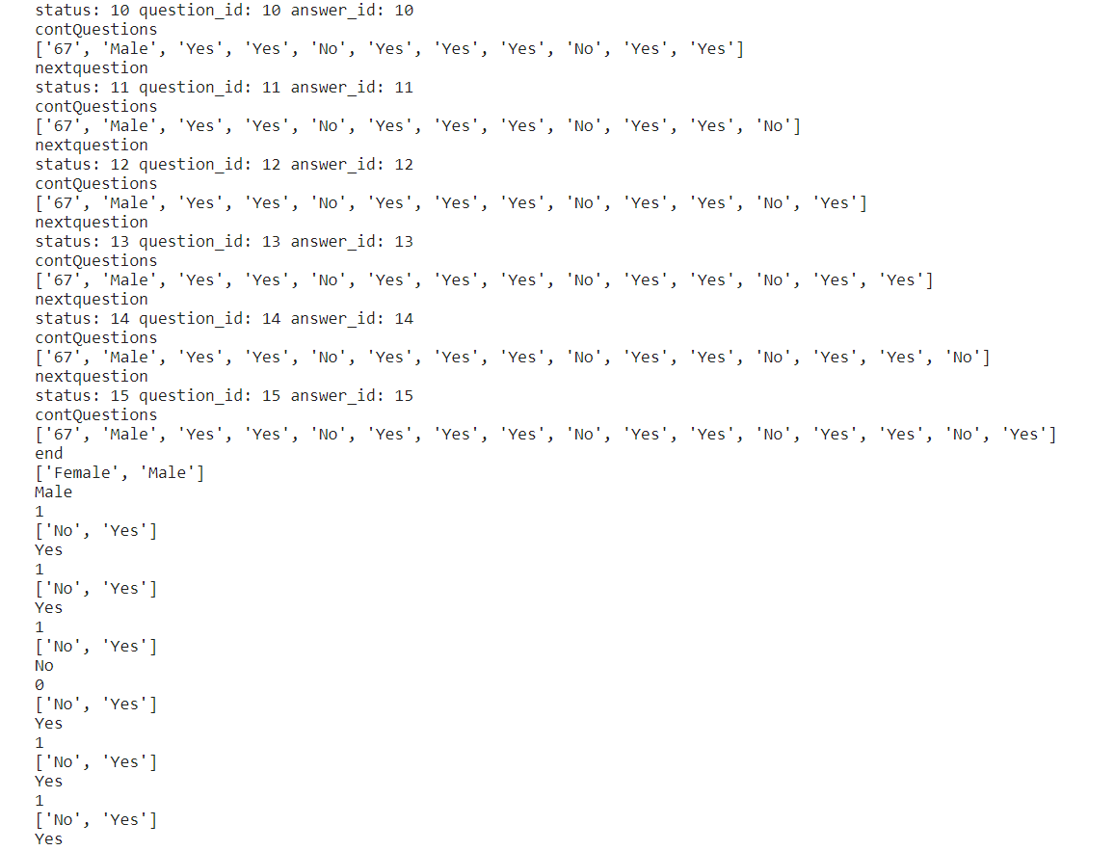
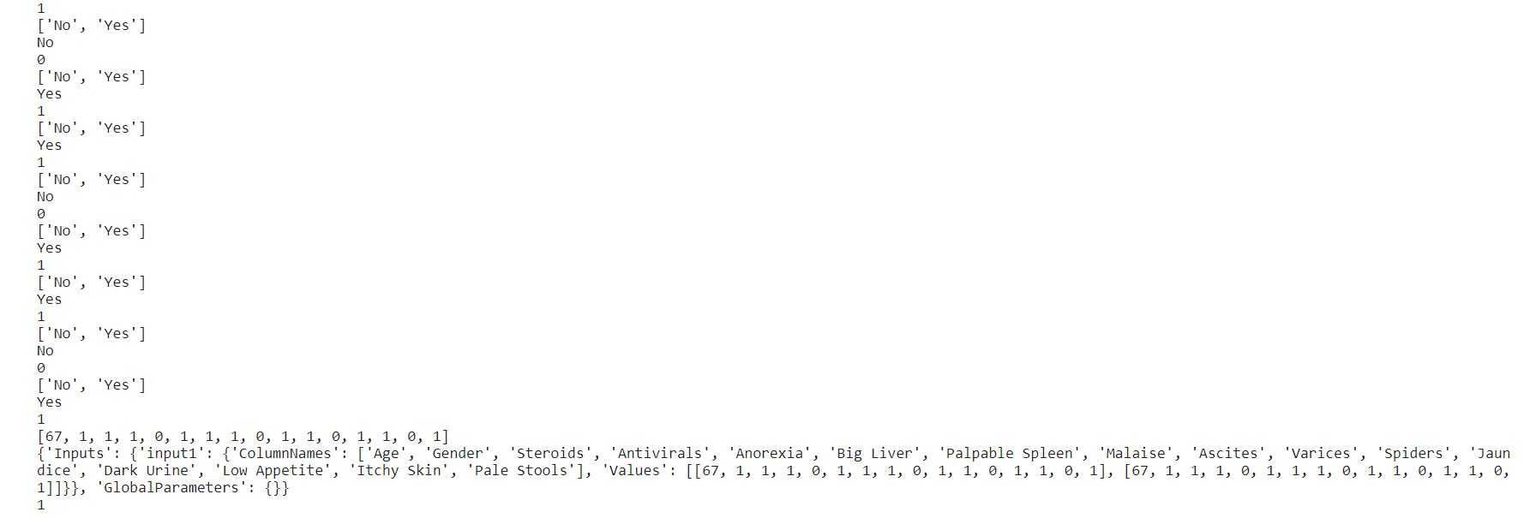
This is the output that gets generated on the Jupyter notebook after answering all the question in the Telegram Bot. As we can see that the code runs successfully and we finally implemented our Telegram Bot in python.

(14). Output in Telegram Bot:

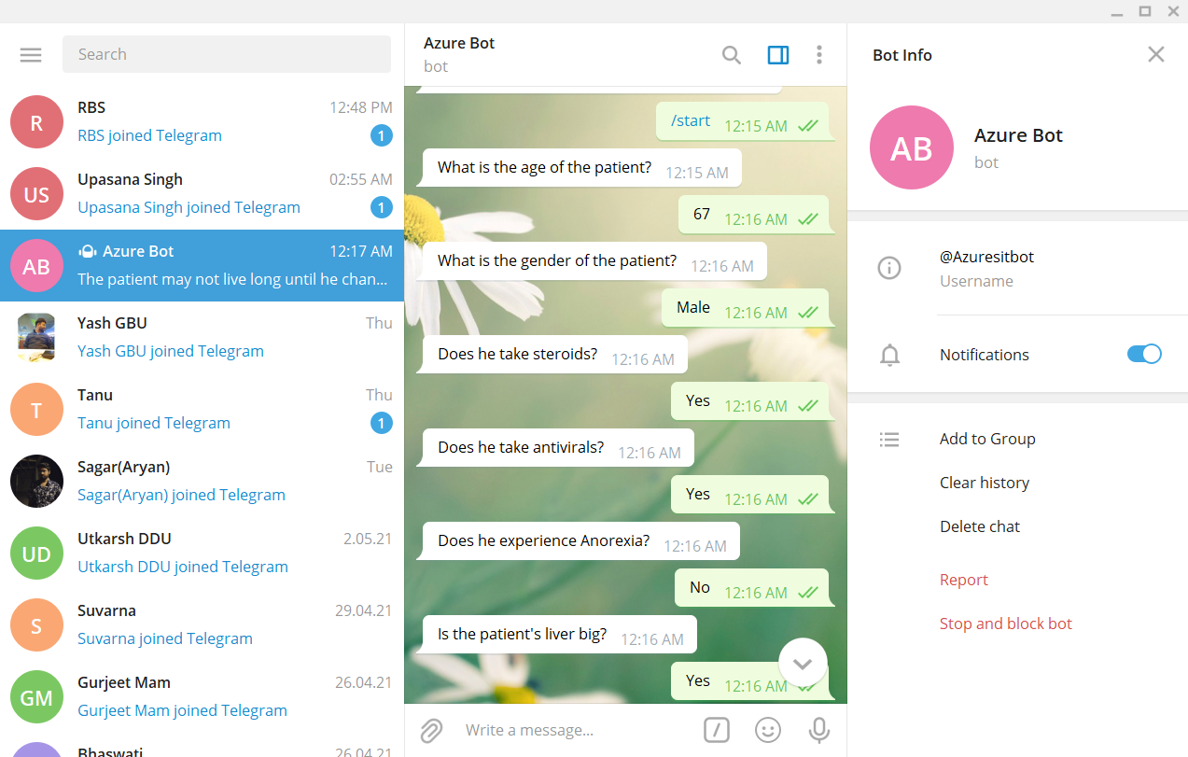

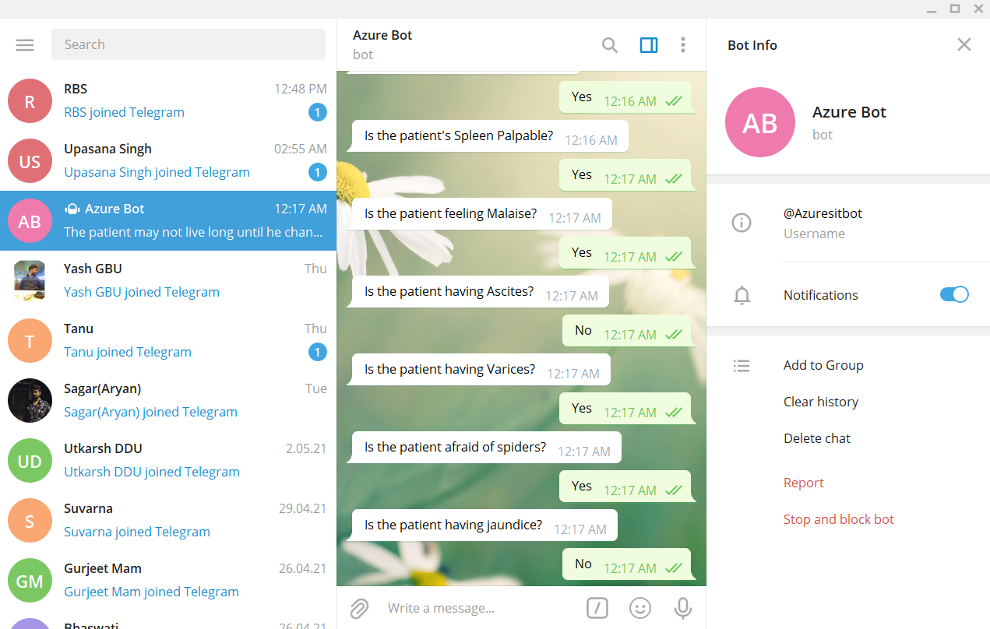

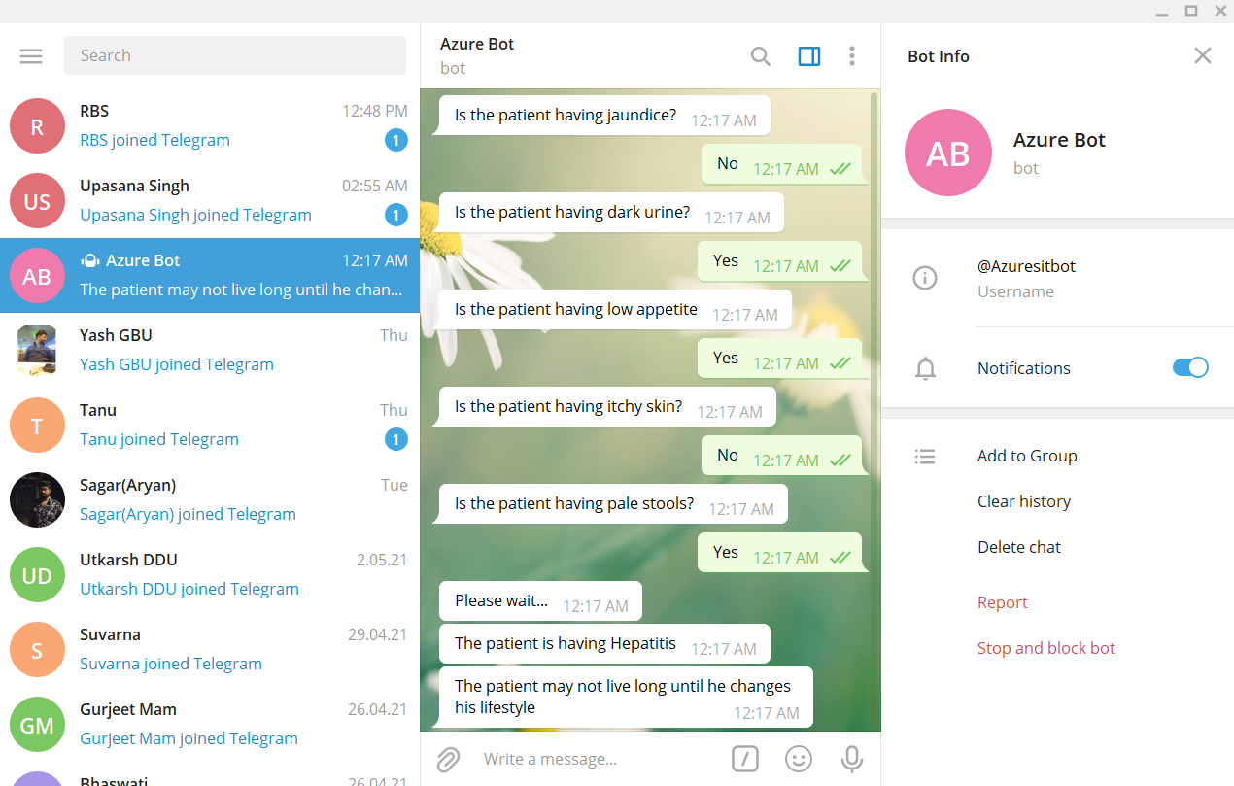

This is the output on the Telegram App. We can see that our bot runs successfully by receiving and comparing the inputs on our deployed model and at the end we get the final output as “The patient is having Hepatitis. The patient may not live long enough until he changes his lifestyle”.

REFERENCES

- https://d2l.deakin.edu.au/d2l/le/content/1029605/viewContent/5442865/View
- https://d2l.deakin.edu.au/d2l/le/content/1029605/viewContent/5442866/View
- https://d2l.deakin.edu.au/d2l/le/content/1029605/viewContent/5442868/View
- https://d2l.deakin.edu.au/d2l/le/content/1029605/viewContent/5442880/View

CODE

